
The Republic of Uganda

MINISTRY OF GENDER, LABOUR AND SOCIAL DEVELOPMENT

REPORT OF RESETTLEMENT & MANAGEMENT OF STREET CHILDREN

KOBULIN YOUTH SKILLS TRAINING CENTRE

JULY TO SEPTEMBER 2019

1. Introduction:
This is the report for management and resettlement of street children from Kampala transiting through Kobulin Youth Skills Training Centre-Napak, Karamoja sub region. The returnees’ children were received at Kobulin from Kampiringa. The team at Kobulin headed by the Principal of Kobulin Youth Skills Training, and 6 Social workers working with support from C&D Moroto District participated in this exercise of rehabilitation, tracing and resettlement.

2. SPECIFIC OBJECTIVES:

- To rehabilitate, trace and re unite the children with their families /community and schools.
- To provide welfare, protection, psychosocial services for vulnerable children of Karamoja.
- To provide tailored skills training and socio-economic support to the vulnerable children and youth
- To provide health services to the children by screening them for different illnesses.

3. ACHIEVEMENTS
- Medical screening: In partnership with nearby health facility we facilitated medical screening and treatment to the 207 children who were received by the social workers at the centre with support from Lorengechora health center staff. The 207 children were screened for malaria, tuberculosis, syphilis and HIV/AIDS. Those who were found sick were put on treatment by the health workers.
- Repatriation of 207 children were was successful, we engaged the Ministry Coaster in the transportation of children from Mpigi to Napak and within Wakiso also, 207 children were returned from Kampala streets 199 females and 07 males, while 10 children were intercepted on their way from Moroto to Kampala and brought to Kobulin for rehabilitation and resettlement by Police in Napak, who were worked closely with Napak district.
- Registration, this is critical activity at the facility: On arrival these children were registered by our social workers to ascertain their homes and other details for tracing and resettlement.
- Surveillance on high way: A total of 10 females who were intercepted on their way to Teso for casual work and successfully rehabilitated and resettled to their homes.
- Pyshco social support: All the 217 children were provided with psychosocial support both at the centre and during resettlement with their parents and care givers. This includes life skills training, group counselling and guidance, elementary education.
- Apprenticeship and entrepreneurship skills training: A total of 52 girls and 1 boy were enrolled for skills training at the center.
- Re-integration: A total of 217 children were successfully rehabilitated, their homes traced and re integrated as planned.
- Sports and recreation: We provided comprehensive package of sports and games activities (football, netball volley balls, ludo, drafts, mueso, skipping ropes) were provided to children to strengthen their resilience, but also coping mechanism.
- Guidance and counselling ;on daily basis, morning and evening individual and group counseling was conducted to prepare children for life at home, school and skills training.
- Children were also introduced to prayers both morning and evening by one of social worker who is reverend to help them understand the danger of reckless life on the streets.
- Resettlement package: As part of the resettlement package, all children were provided with second hand clothes on arrival for decency while at the center, but also to prepare them for reunion with parents and guardians.
- First aid : In a bid to avert any emergency sickness, children were provided with first aid kits (assorted drugs to handle minor illness, serious cases were referred to nearby health facilities.

LESSONS LEARNT
- Out of the 217 children resettled, 88 of them were from Lopeei sub county, Napak district alone.
- Most of the children returned from Kampala streets were not willing to enroll for the skills training instead wanted government to open for them businesses to manage.
- Most of them did not want to go back to school due to lack of scholastic materials and opted to only go to schools with boarding section.
- A majority of the children returned from Kampala streets were girls.

CHALLENGES
- Some of the roads to the children’s homes are not easily accessible and this makes resettlement to drag because the team has to look for an alternative road to enter a particular village.
- The mode of transport is limited. The cars are usually not enough to carry large numbers of children with their resettlement package at once.
- 2 children are from Moroto district, this anew phenomena given that it is the first of its kind.

ACTION POINTS.
- Continuous sensitization is needed to help the parents and care takers to understand the concept of child protection.
- Facilitation of follow up sessions is very vital to help the centre and government in programming.
- There is need to strengthen partnership with other child focused organizations to end out migration in the region.
- There is need for the enforcement of laws by stakeholders in order for the parents and care givers to end out migration in the region.

CASE MANAGEMENT STORY
Aguma betty a female of 8 years and Edepu Phillip a male of two years were abandoned by their parents in matany their maternal home with their grandmother who later died in march. Life for the children became hard as the caretaker had passed on leaving them helpless being both young children they couldn’t manage to stay alone. On 13th July 2019 the two decided to leave Matany to start their journey to Kampala on foot to find their parents on empty stomachs. On their way they were intercepted by the POLICE CFPU around Lokiteded before Lorengechora town council and taken to Lorengechora police post and later brought to Kobulin for further rehabilitation and resettlement.
While at the centre, Philip was put under medication for cough malaria and also nutritious feeds to regain. The two children were rehabilitated for two weeks later resettled on the 27th of July in Amuria district by the Child Family Protection Unit of both Amuria and Napak districts. Family being the best place for the child to stay and also following the best interest of the child the parents could not be arrested but signed an agreement to commit themselves to providing basic needs. This brought a smile to the children’s faces as they felt relieved from the sufferings and also Betty was to be enrolled in school as soon as possible.

CONCLUSION
Kobulin Youth Skills Centre is currently implementing its mandate as required for by government. However, there is need for regular resource allocation to the facility to provide for livelihood and skills training and start up kits to our youth in Karamoja region.

Photo gallery showing different activities in the rehabilitation, tracing and resettlement circle.

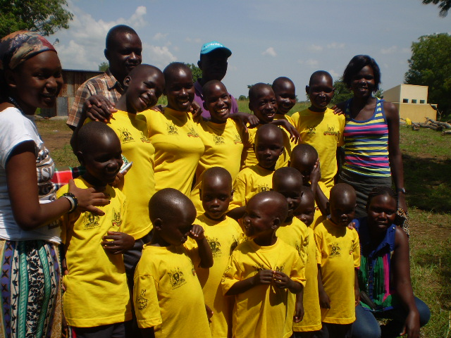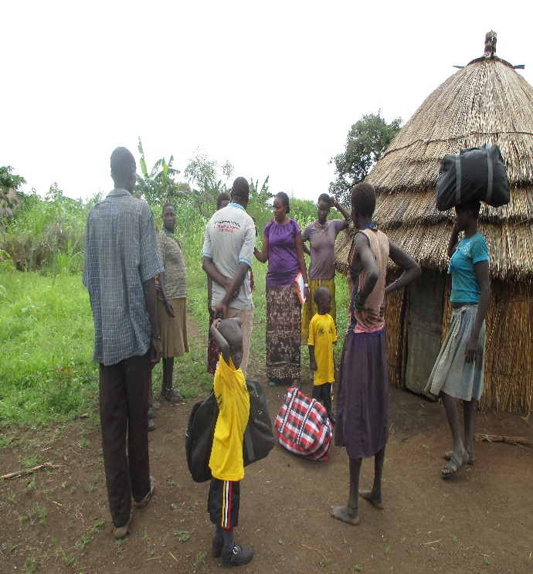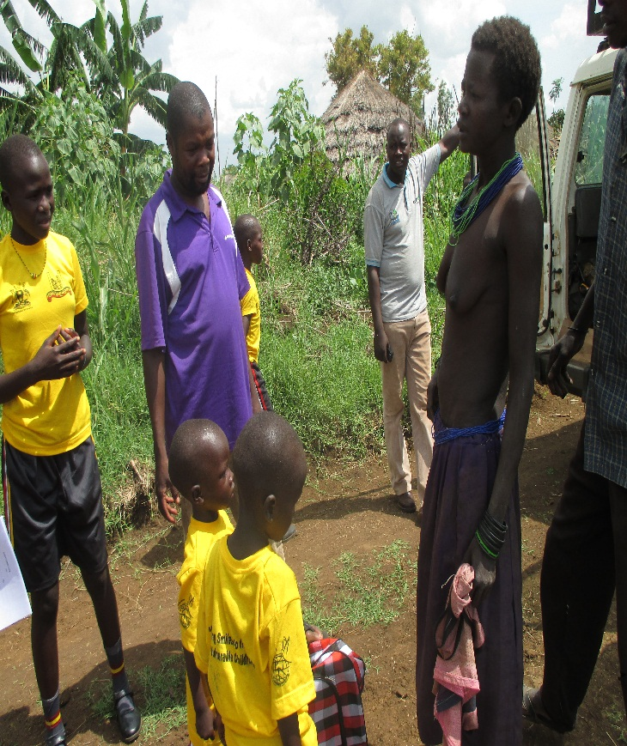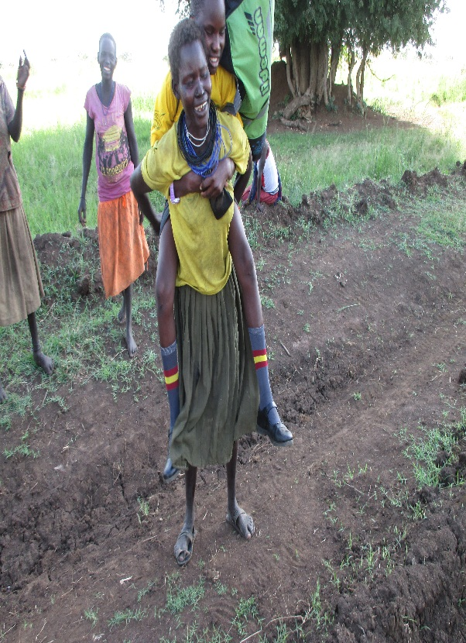

Social workers with parents and care givers during the resettlement exercise.

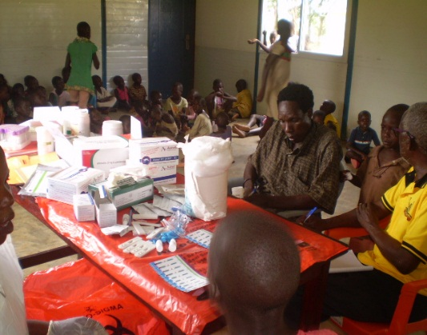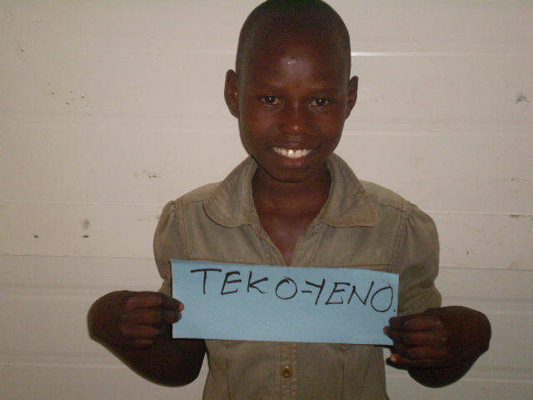
Photo of medical screening of returnees, one child smiling during registration exercise.

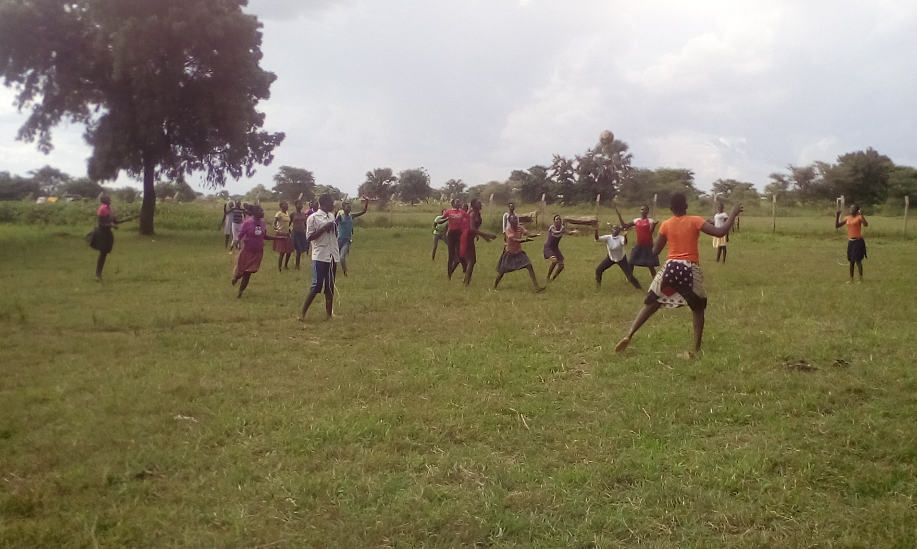
Children engaged in games and sports.
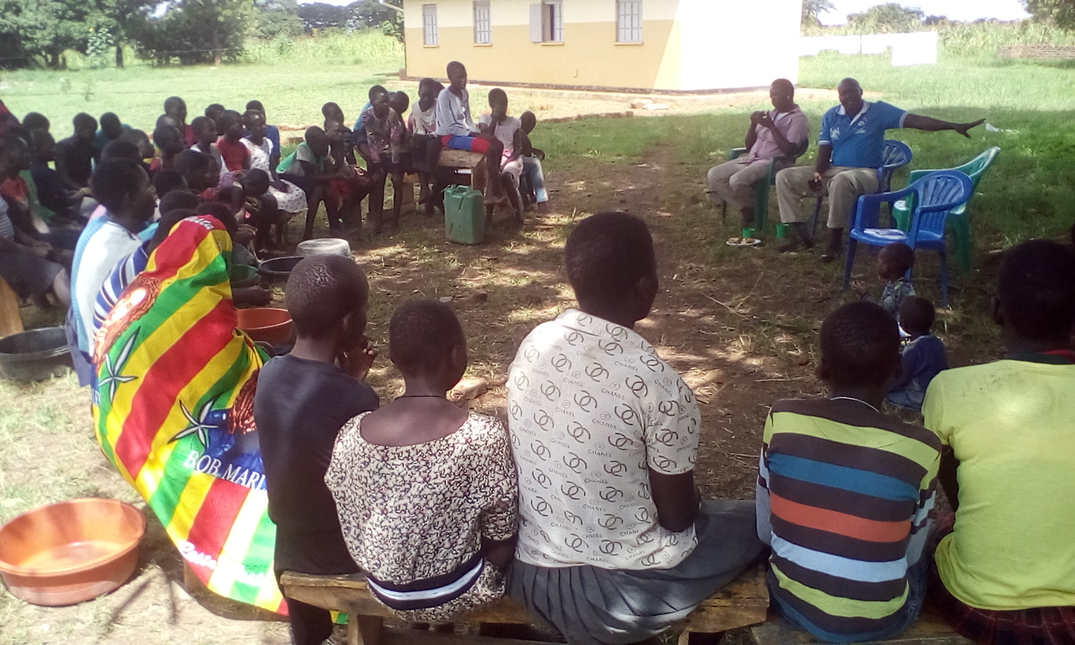
The child and family protection unit police Napak; talking to the children at the centre about outmigration
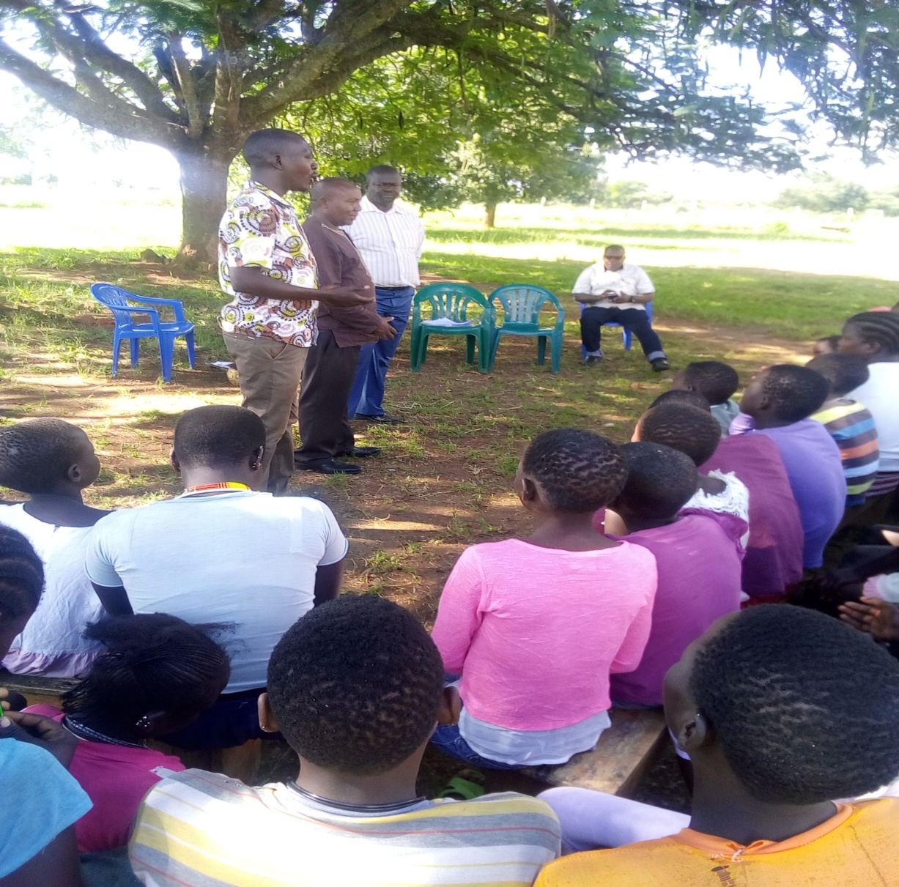
Above is the Commissioner Youth and Children talking to children at the facility about the danger of life in the streets

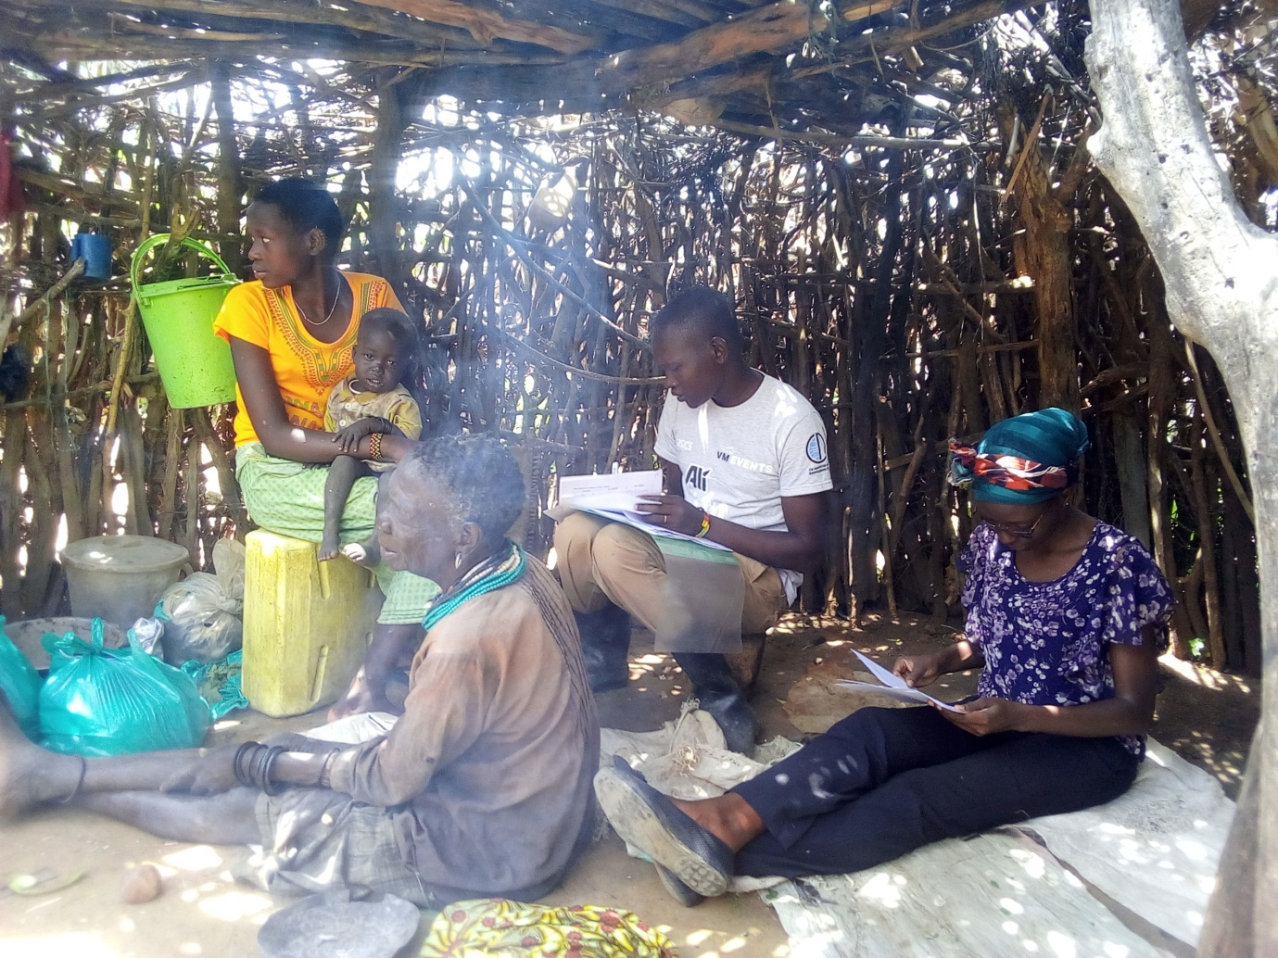
Social workers conducting reseetlement of children in their homes.
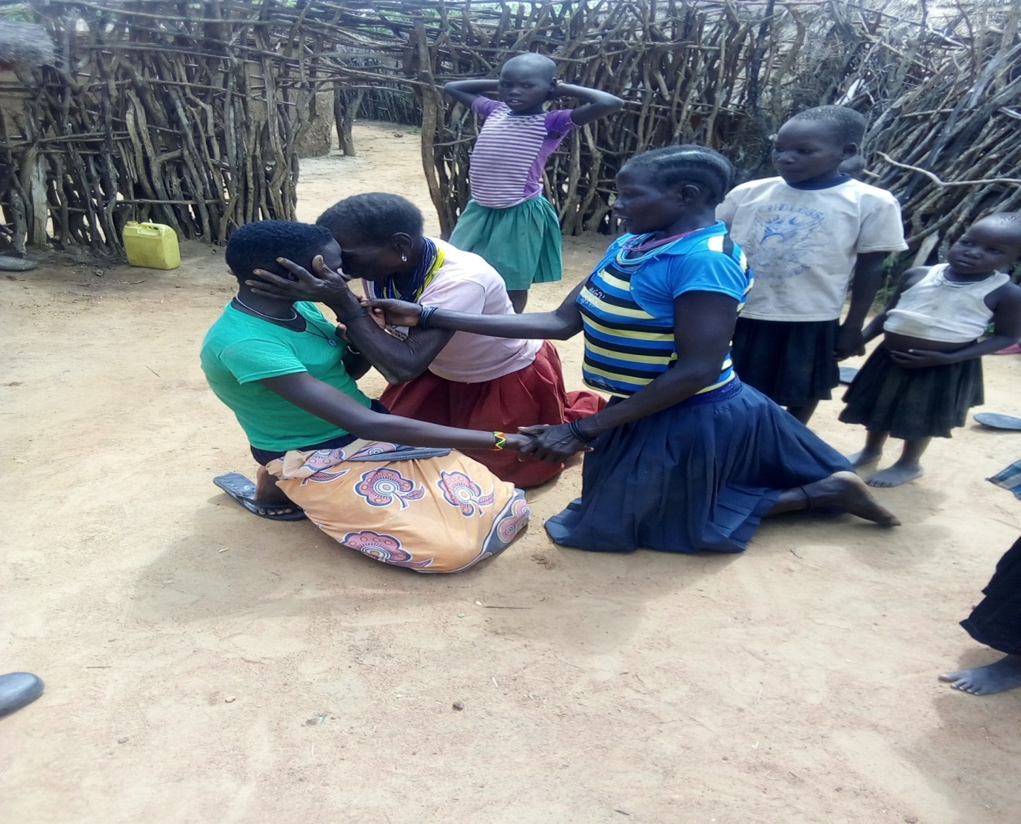
Mother expressing happiness to see the daughter back

